Use-Case Realization Report
Take Exercise

Issue <1.0>
Revision History
Date | Issue | Description | Author
<dd/mmm/yy> | <x.x> | <details> | <name>

Table of Contents
1. Brief Description 4
2. Flow of Events 4
2.1 Standard Flow 4
3. Interaction Diagrams 4
3.1 Collaboration Diagram for Take Excercise 4
4. Participating Objects 4
5. Class Diagrams 5
5.1 Class Diagram for Take Excercise 5
6. Derived Requirements 5

Use-Case Realization Report
Take Exercise

Brief Description

Flow of Events

Standard Flow
- User clicks the “Take Exercise” button.
- Exam Controller will generate the exercise questions.
- User can navigate these questions, viewing the next or previous question, or view the correct answer.

Interaction Diagrams

Collaboration Diagram for Take Excercise
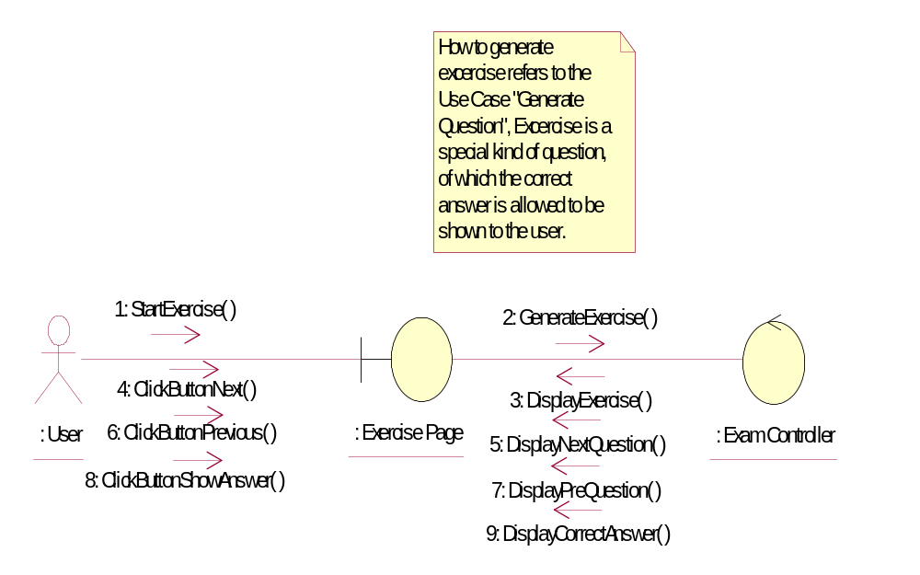

Participating Objects
: Exam Controller
This cotroller will in charge of creating exam questions, monitoring exam progress, like the user answers, and the time spent, navigating questions etc. It will also save the result into Exam Result table and Exam Result Detail table.
: Exercise Page
This Excercise Page provides an interface for user to practice for the exam, so that the user will know the look&feel of the real exam.
: User

Class Diagrams

Class Diagram for Take Excercise
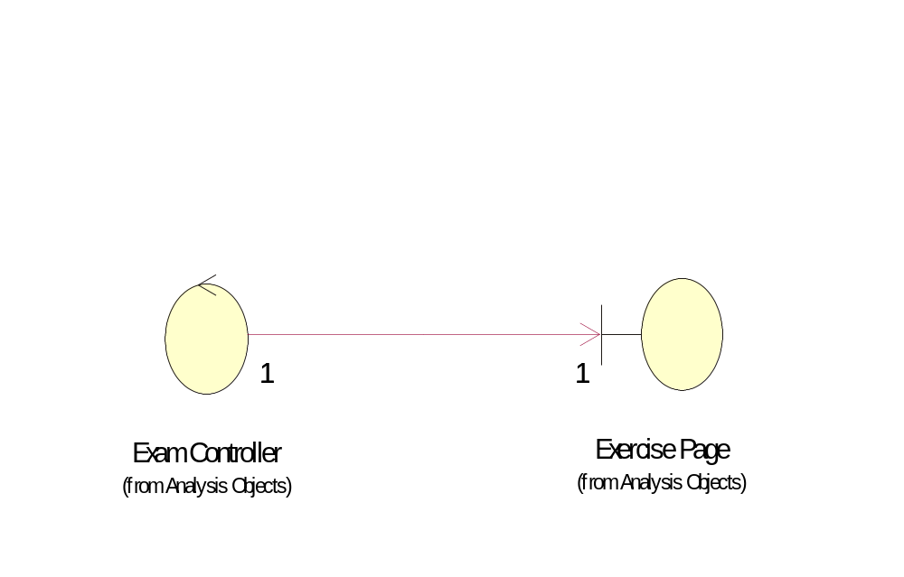

Derived Requirements
No derived requirements.

